Banyule District Cubs
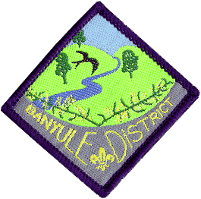
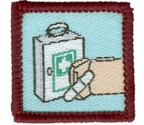
Formerly Red Level 2
First Aid Course
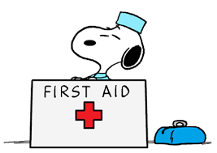
Saturday 30th May & Sunday 31st May
1st Ivanhoe Scout Hall
49 Hawker St Ivanhoe

Cost: $30 per Cub (includes 2 lunches and 1 dinner)
Please advise dietary requirements.

Eligibility: Cubs who haven’t done the course and are due to go up to Scouts
by end of June 2027.

Equipment: Full uniform, named water bottle, personal first aid kit
The personal First Aid kit should fit in a small container & this put together by the Cub.
((Akela’s will be provided with list of material.))
This is required for Sunday’s training and testing sessions.

Saturday: Arrive 10.50 for an 11-00am start (need to have time to sign in).
Finish: 7-30pm.
Cubs will be taking part in training in a wide range of aspects in First Aid.
Of course, we be having breaks throughout the day for some fun

Sunday: Arrive 9.15 for a 9-30am. Finish by 2pm
A First Aid kits session first, then we will start the testing session.
Cubs are to be paired up and tested across a number of different scenarios where they will treat the ‘victim’ for the problems they find along with a written multiple choice test.

Cubs need to be signed in and parents to leave a contact number for both days
If your Cub is absent for a small part of the weekend, please write on the form the time they will not be attending.

Return to Kaa as soon as possible

Banyule District Cub First Aid Weekend:
Cub Name.............................................. Pack Rosanna..
Dietary requirements..........................................................................
Will be absent from the Course? (When?).......................................................
Payment methods:
Via EFT,
Banking details
Banyule District Cub Scouts
The BSB is 633 000 ( Bendigo )
A/C 152262291.
Reference : Name, Rosanna & event – e.g. Mary Jones – Rosanna – First Aid

Signed..................................... Phone No...................................

Any questions,
Wayne Renfrew (Kaa)
0411 121 495
wayne@rosannacubs.org
…or on Whatsapp

